**CP Club 365 Days Challenge**

**Programming language – C++**

**Problem Statement**

<https://www.codechef.com/problems/COKE>

Git :- <https://github.com/Vedantbharad2603/CP_club_365_Days>

**Your Code**:

// 0x117Day of 0x365Days challenge

// VEDANT BHARAD

// 11-2-2023

#include<bits/stdc++.h>

using namespace std;

int main() {

    // your code goes here

    int t;

    cin>>t;

    while(t--){

        int n,m,k,l,r,f=0;

        cin>>n>>m>>k>>l>>r;

        vector<int> ved;

        for(int i=0;i<n;i++){

            int c,p;

            cin>>c>>p;

            for(int j=0;j<m;j++){

                if(c>k+1){

                    c=c-1;

                }

                else if(c<k-1){

                    c=c+1;

                }

                else if(c>=k-1 || c<=k+1){

                    c=k;

                }

            }

            if(c>=l and c<=r){

                ved.push_back(p);

                f=1;

            }

        }

        if(f!=0){

            sort(ved.begin(),ved.end());

            cout<<ved[0]<<endl;

        }

        else{

            cout<<"-1"<<endl;

        }

    }

    return 0;

}

**Output (Screen Shot)**:

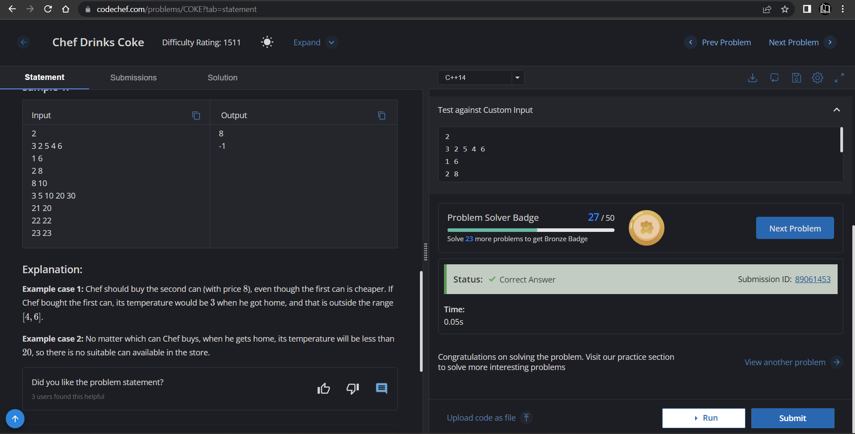

**Understanding about problem:**

* In this task I need to return price of Coke,which coke’s price is less and it’s temperature is also less so he can go home and temperature will be in given range

Note: If you can't understand the problem, feel free to contact us and we'll help you. Please don't copy and paste from anywhere.

ALL THE BEST

Team CP Club